Bemidji Area Public Schools
Paul Bunyan Elementary
“Together we are Better”

“Guiding Learners on Their Path to a Bright Future”

Wednesday Packet Newsletter
April 2018
From the Principal’s Desk

SEL Family Night

Peacemakers Resources have been given a grant to come into our school every other week and do a social-emotional lesson with our students. These lessons teach students about self regulation, emotions, breathing, social skills, our brains and much more.

Luckily, we have a chance to share that information with families! Our SEL Family Night invites you to come to school and learn more about our social emotional lessons. We hope to bridge the connection between home and school techniques so students have a well-stocked “tool box” of tricks they can use anywhere.

When: Thursday, April 26
Time: 6:00pm to 7:30pm
Where: PBE

Yoga Calm

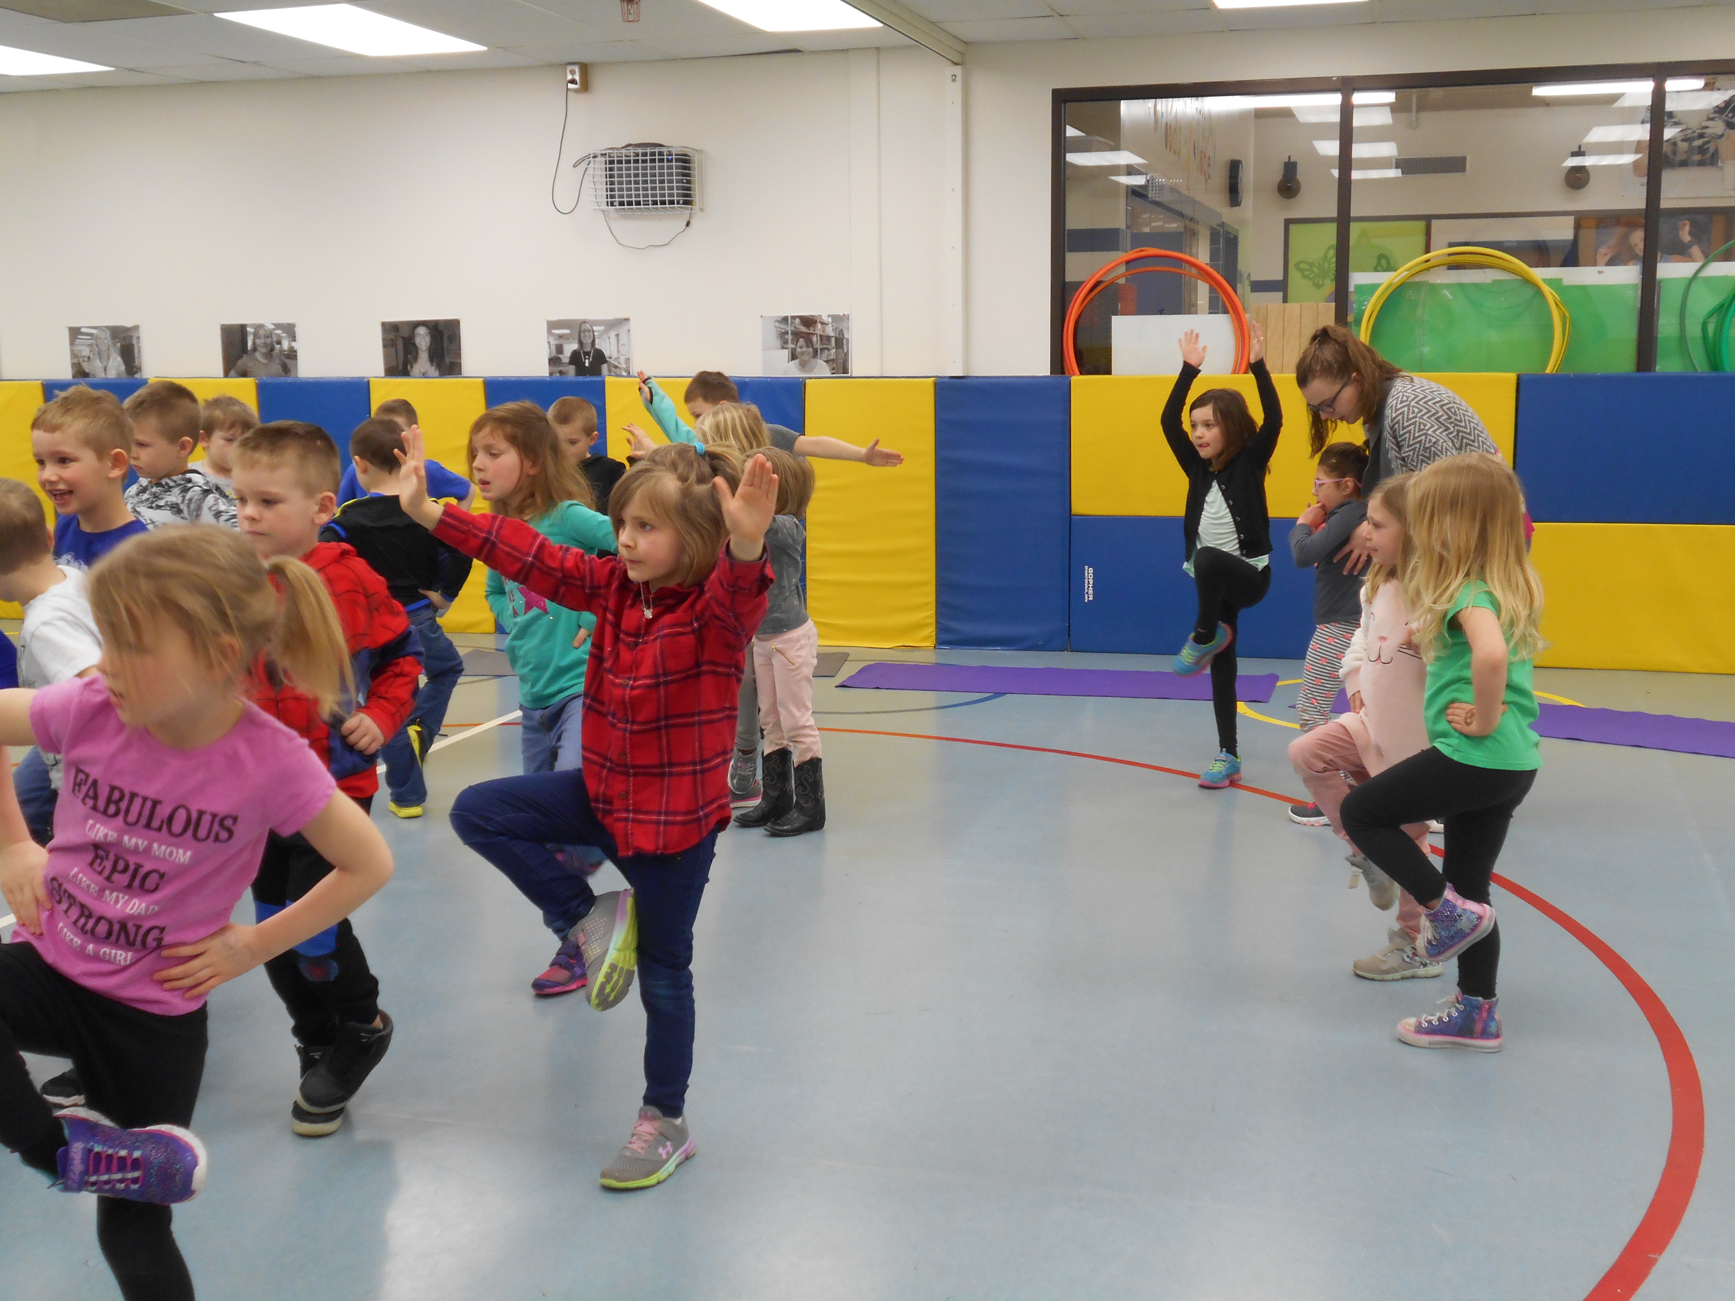

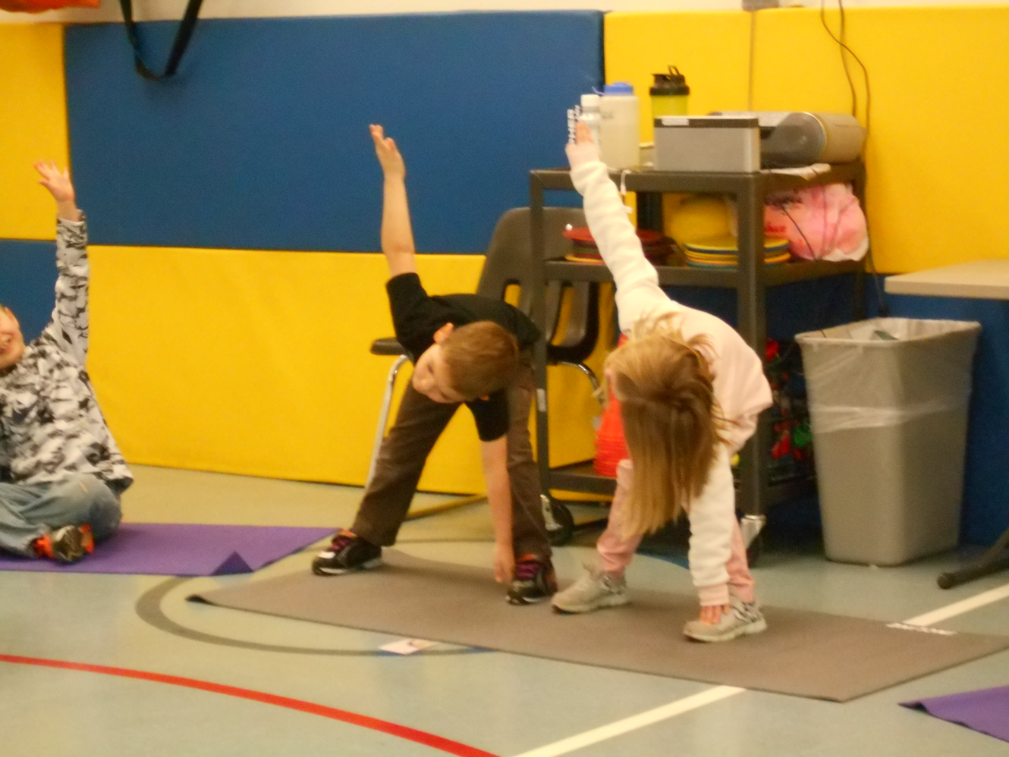

As part of our social emotional lessons from Peacemakers our students learned Yoga Calm. Our students thought it was a lot of fun and harder than it looked!

MAP Testing

It’s that time of year again! Testing time! We will be giving the MAP (Measures of Academic Progress) to our students on May 7 and May 14. We test our students’ progress in reading and math.

We need your help, parents. Please help your child get a good night’s sleep prior to the test dates. We will continue to practice skills they have been working on and will also provide a little skit of things they need to watch while testing; like clicking through the test (!), not listening and not asking questions when they have one. Overall, just make sure they get enough sleep, have a good start to the day with a hug and kiss from you!

Handicap Parking Spaces

A quick reminder to not park behind a car parked in our handicap parking area. Last month a parent was blocked in for a short period of time. Thanks for your help.

Attendance

Our students love being in school! Our attendance is STILL fabulous! Our district and school strives for at least 94%! It is so important for students to make an early habit of being in school everyday … unless they are sick. Then it is important to stay home and get well!

Thanks for helping to instill the importance of good school attendance!

BE PRESENT!

PBE Tidbits

*Please drop your child off at Door #2 no earlier than 7:40am; we’ll make sure your child gets to where they need to be

*Enter door #2 to wait for your child after school; the door opens at 2:15

*Please sign your child out with Lori, our secretary, if your child leaves school early.

*School hours are 8:05 – 2:25

*Call Lori if after school plans change for your child.

* Please do not park in the bus parking area.

* Please drop your child off at door #2 and make sure they are on the sidewalk before you leave.

Dates to Remember

May 28 No School

SEND THEM EVERYDAY!

